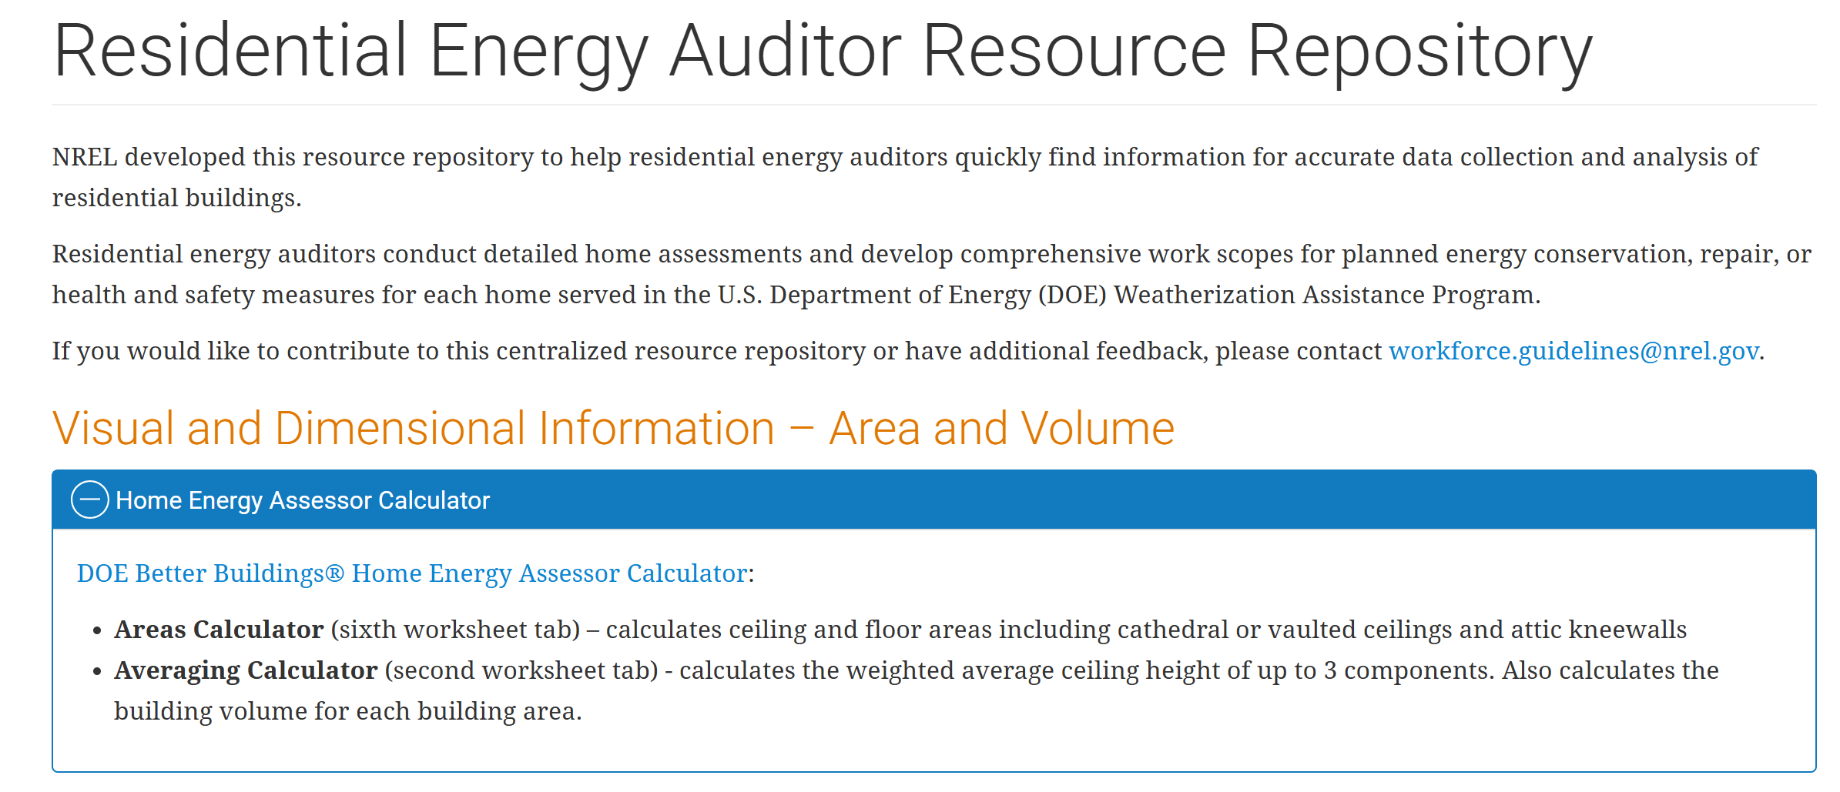
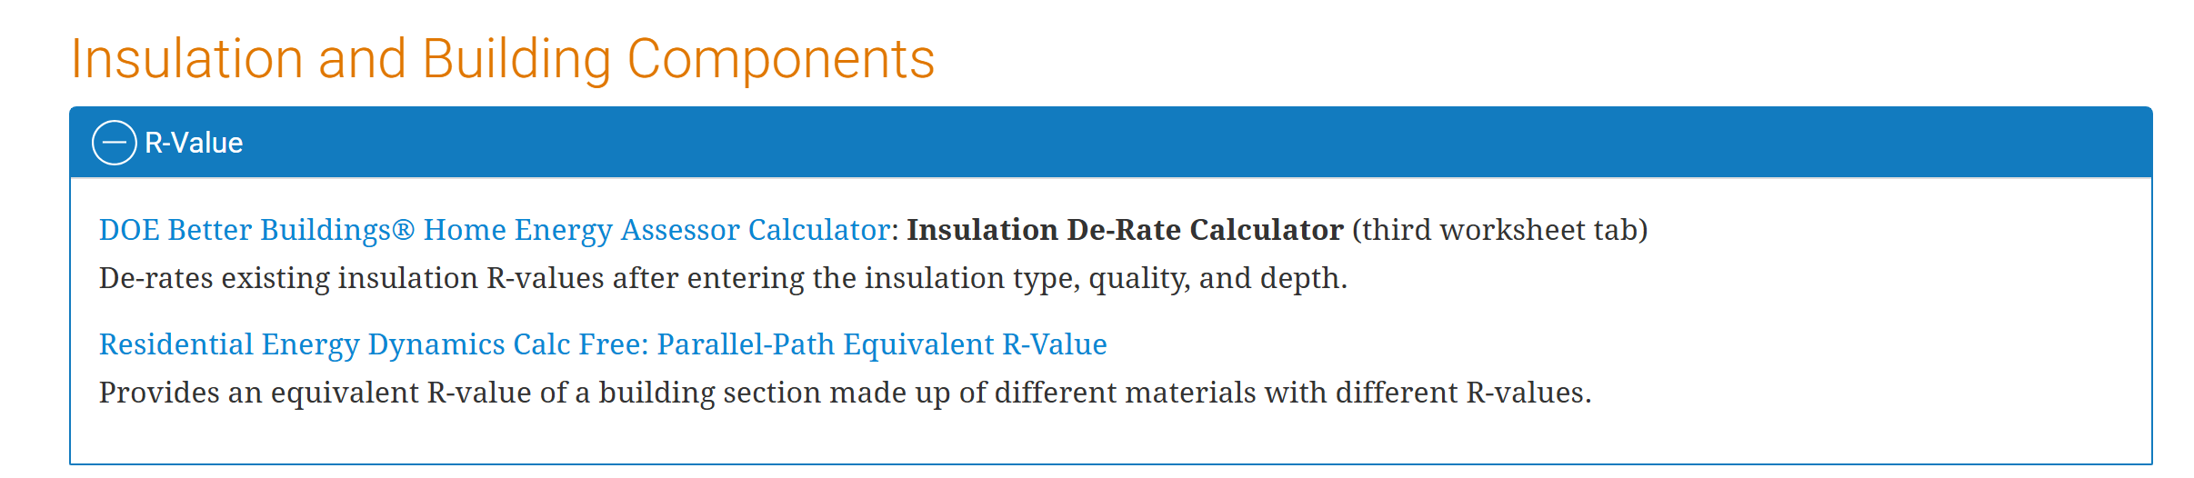
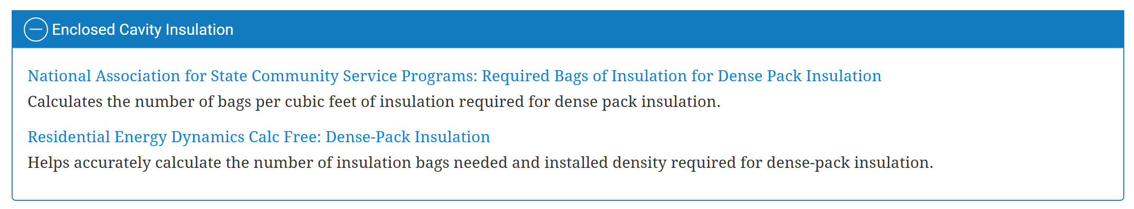
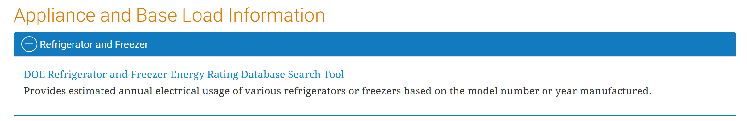
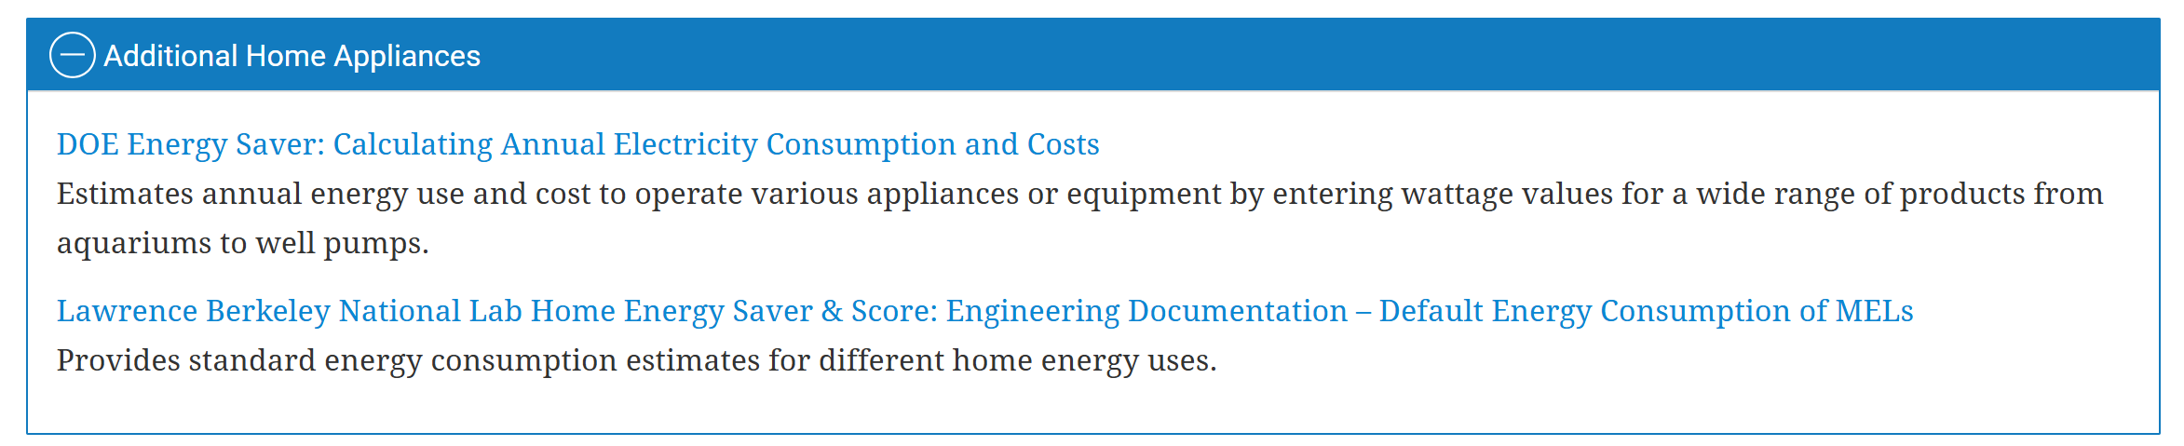
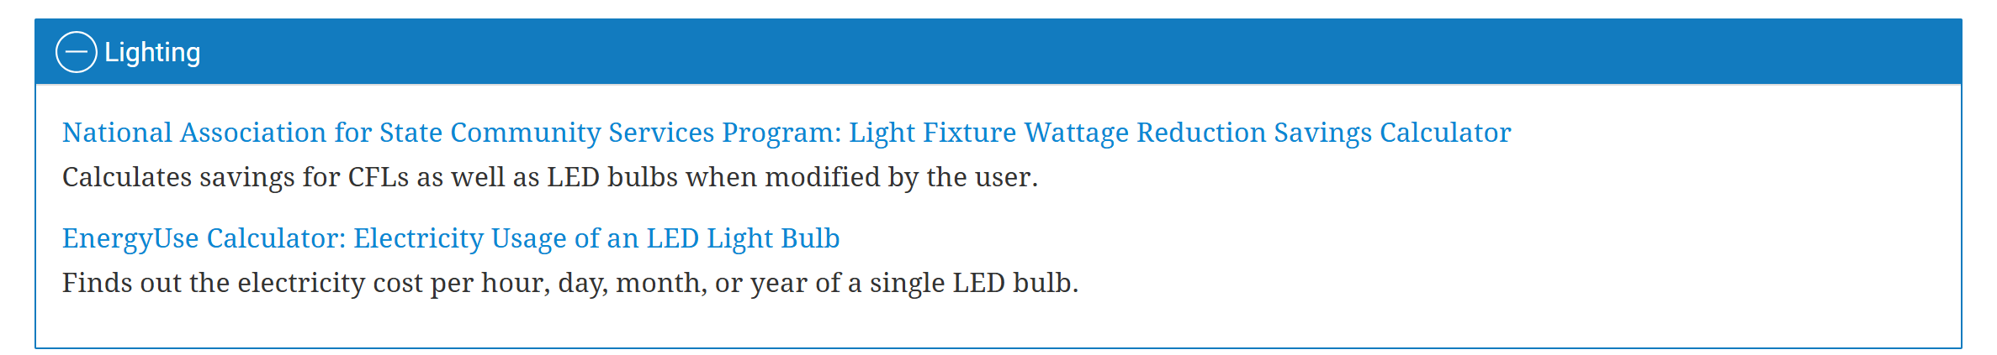
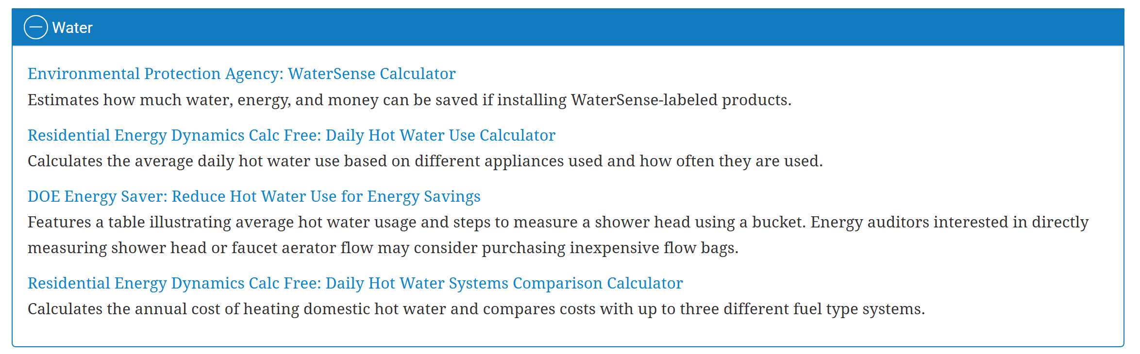
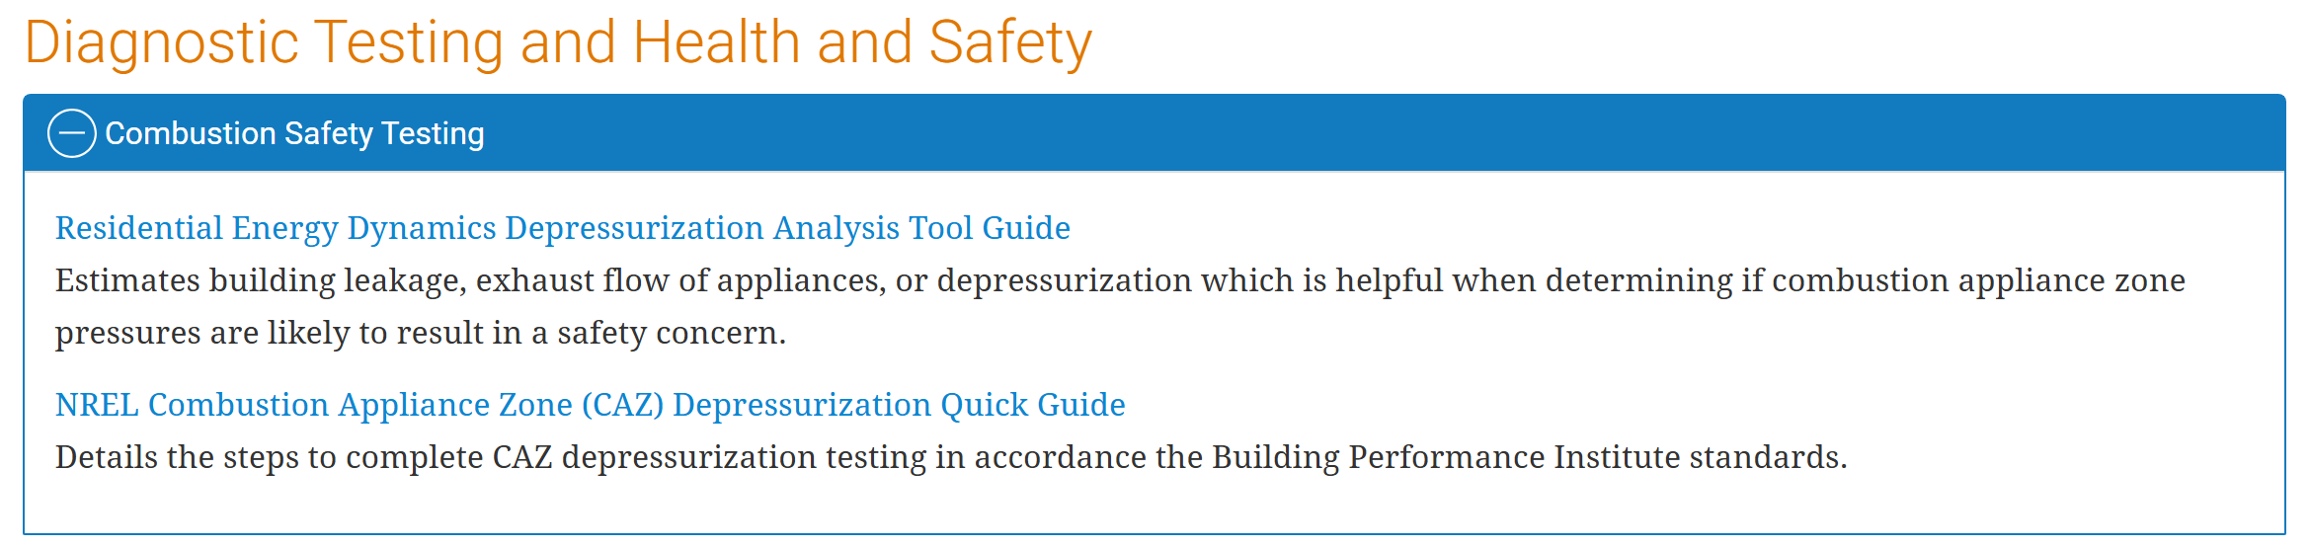
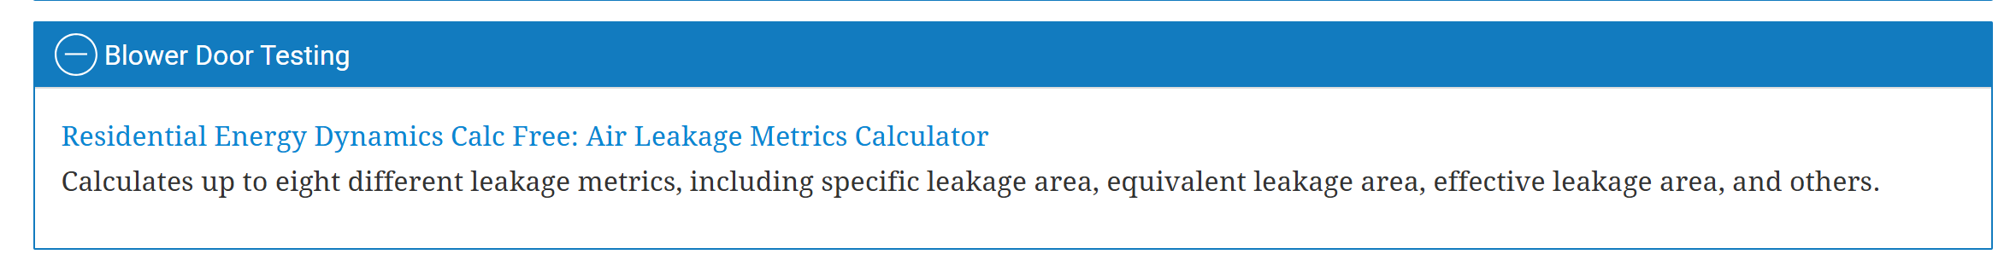
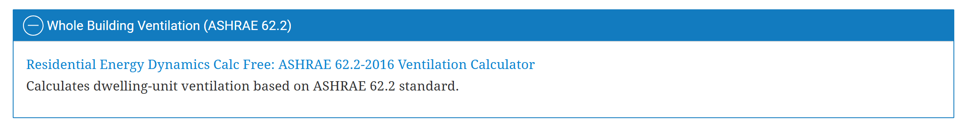
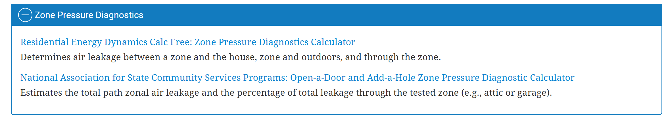
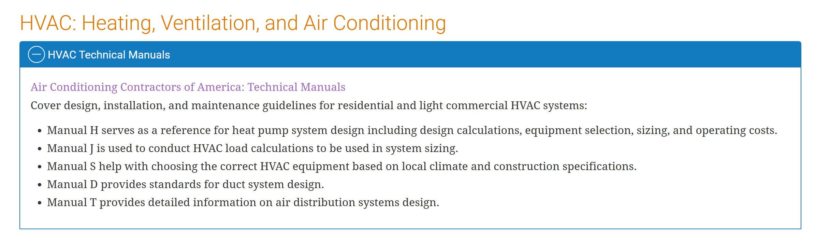
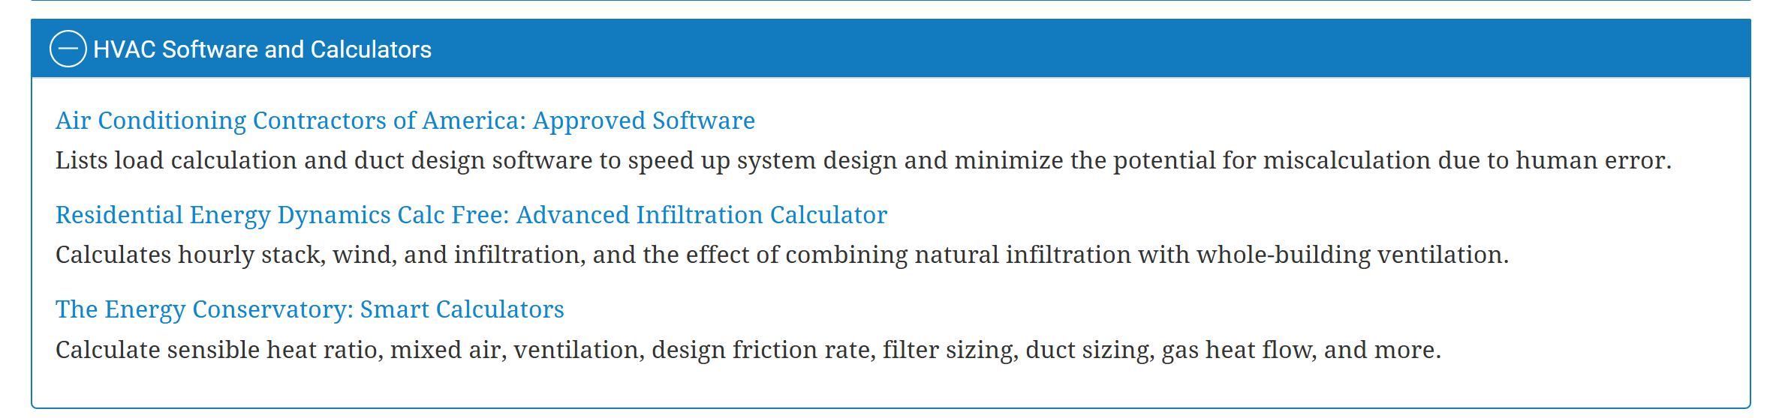
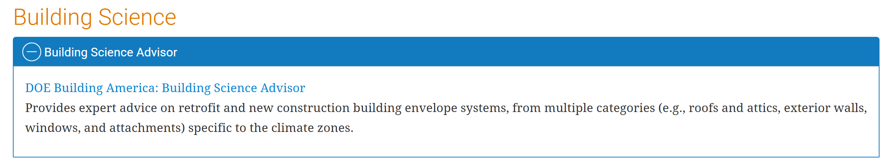
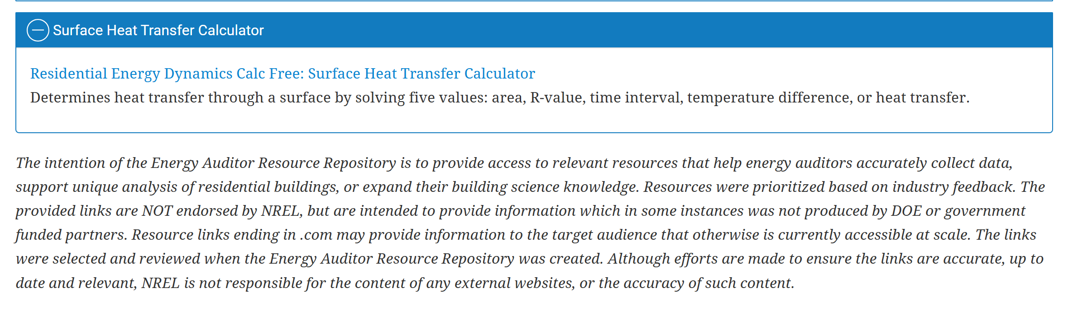

Links:
https://energyusecalculator.com/electricity_ledlightbulb.htm
https://www.acca.org/standards/technical-manuals
https://www.acca.org/standards/approved-software
https://www.energyconservatory.com/tec-smart-calculators/?utm_campaign=BP%20Newsletter&utm_medium=email&utm_source=Net-Results&utm_content=TEC%20BP%20Newsletter%20March%2028th%202023

